

My travel Blog

(How to d.school)



Silicon Valley

How to *D.School*

---by Henry

2018

Introduction

(What is “*d.school”*? The d.school---officially known as the Hasso Plattner Institute of Design. It a place at Stanford where students from different backgrounds could come to nurture their creative talents and apply their newfound skills to tough challenges and solve real life issues. Project-based classes are team taught by faculty members from all over the university and by industry practitioners. Students learn by doing and tackle real-world challenges, usually in multidisciplinary teams. Beyond just graduate students, executives from all over the world attend workshops, and k-12 Lab works with children and educators to help spread confidence in their creative abilities. ---reference to the book *Creative Confidence* by Tom Kelley & David Kelley.)

Ambiguity

I was the youngest member of the group. Most of the members are entrepreneurs, managers, technicians, and even top executives from well-known companies in Hongkong. This was a diverse group which was consisted of people from all walks of life (two professors-also our leaders, businessmen, entrepreneurs-the majority and a student-me) and of different generations varying from post-70s to 2000 millennials. Everyone except me in the group had more or less taken several D.classes and they took this trip to better reinforce what they’d learnt in class previously. However, I was just a “new-be” who didn’t even know what D.class was about, plus it was also my first time to come across “Strategic Innovation & Design Thinking” such a concept. I felt overwhelmingly anxious for not knowing how was I going to fit in such a group or how to catch up with them in class or what could I learn throughout this journey？

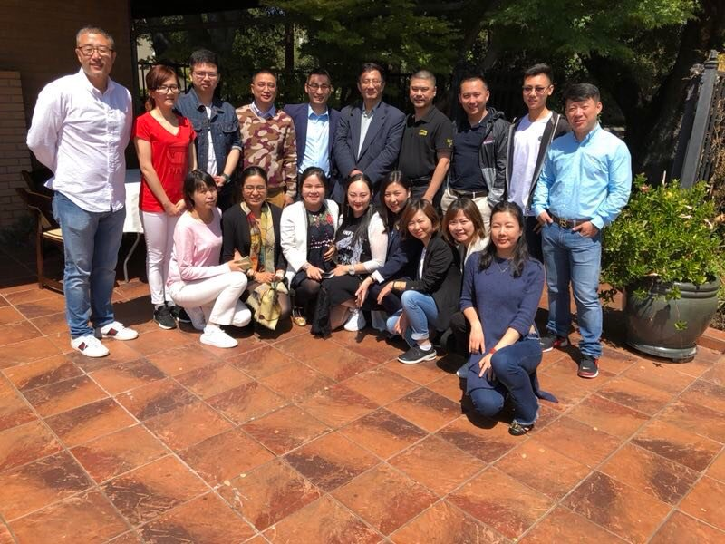

Fellow classmates

Frank Gao

Jack Zhang

me

We Landed

After we arrived in San Francisco at midnight, no sooner than we reclaimed our luggage and got out of the air-port, someone in the group proposed that we should go for a decent late-night meal as our successful arrival ceremony and more for everyone was utterly hungry, suffering from the jet leg and apparently the airline meal was far from enough to satisfy our stomach. It took us half an hour drive to get to the restaurant. It was a nice Chinese cuisine restaurant with all kinds of authentic Shanghai food and we had a table-full dishes. I guessed this was the only way for us to refresh from the long and tiresome journey. After all, ‘food is the paramount necessity of people’ as people say. We needed to have a good sleep to regain our energy and prepare ourselves for tomorrow-the official start of our D.class journey in America! As much as I wanted to turn in, the food in my stomach and the excitement of being in a new continent in my mind kept me awake almost for all night. What’s was, our leader-professor Gao (he let us call him Frank) made such a rule that if anyone had not got onto the bus by 7.30am or took a nap during the class, then the person needed to donate $100 to the group as the punishment and we’d probably use that money to order more food and drinks at table afterwards. Therefore, I set up the alarm at 6.30 just for not being late on the very first day.

  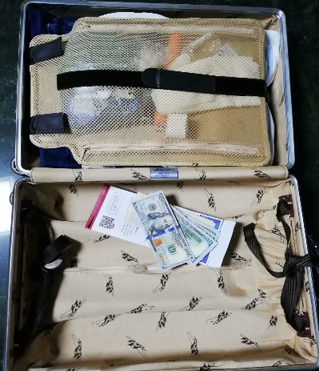 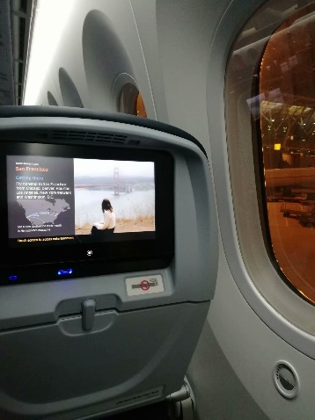

At Stanford

As soon as the alarm went off, I jumped out of my bed, took a quick shower, put on my suit and rushed downstairs, finished my breakfast in the lobby, found and got onto our bus outside. I check the time and it was 7.00 on punch. I couldn’t believe I was able to complete so many tasks in thirty minutes such a shor time, and more importantly, I was garanteed that I could not be more safe. About fifteen minutes later, before we set off for Stanford, professor Zhang (aka Jack) did a count to make sure everybody was on the bus. On the way, a local guide explained the general things about California such as people’s life style, how are the districs divided in an area, the climate there and so on. I didn’t even realize I fell asleep untill Jack told us that we’d arrived at Stanfrod with the microphone. These iconic buildings and pedestrians carrying their backpags reassured me that “yhe~ we ARE at Stanford!”



We were dropped in front of a plain-looking building which I thought was a private mansion. Frank came out from inside and welcomed us. He has his own house near the campus so he got there way ahead of us and he had set everything ready for us. Even though California is famous for its sunshine and warm, comfortable weather, it’s quite chill indoor. Thankfully I brought a coat with me that day. Before we officially begin the lesson, Frank asked us to introduce ourselves to the group in order to break the “ice”. Seeing others stand up, introducing their occupations and basic information on their backgrounds so confidently, I started wandering how was I as a high school student supposed to introduce myself in front of such a business group of people whose average age was twenty years older than mine. When it came to my turn, I just played honest and straight-forward, telling them that I was a high school student and I went on this trip to broaden my horizon and learn new things that I didn’t have access to in my school. Thank god they acknowledged me as a member of them though they felt surprised to have such a young man in the group. Of course, Frank didn’t miss this opportunity to give us the basic introduction about himself. He teaches at d.school at Stanford along with Jack. It’s quite hard to define the relationship between him and Jack. They are partners, coworkers, intimate friends and classmates

classmates as well at d.school. He and Jack take charge of the development of the d.school program in China and both now have successfully set up such program in several universities in China across mainland to southern China special governing district- Hongkong.

“Damn! Such a marvelous introduction compared to mine.” I thought to myself secretly.

After warming up, Frank walked us through the general history of Silicon Valley and Stanford.

I was surprised by the unimaginably close relationship between Silicon Valley and Stanford that they are just like fish and water as Frank explained. Fish cannot survive without water and water loses that sense of life without fish. “Why it felt like we were taking a philosophy class?” I thought. Next, Frank showed us the daily agenda for the whole journey, and what’s exciting about it was that we were going to visit one of the Google campus and would be given a lecture by an executive there this afternoon.

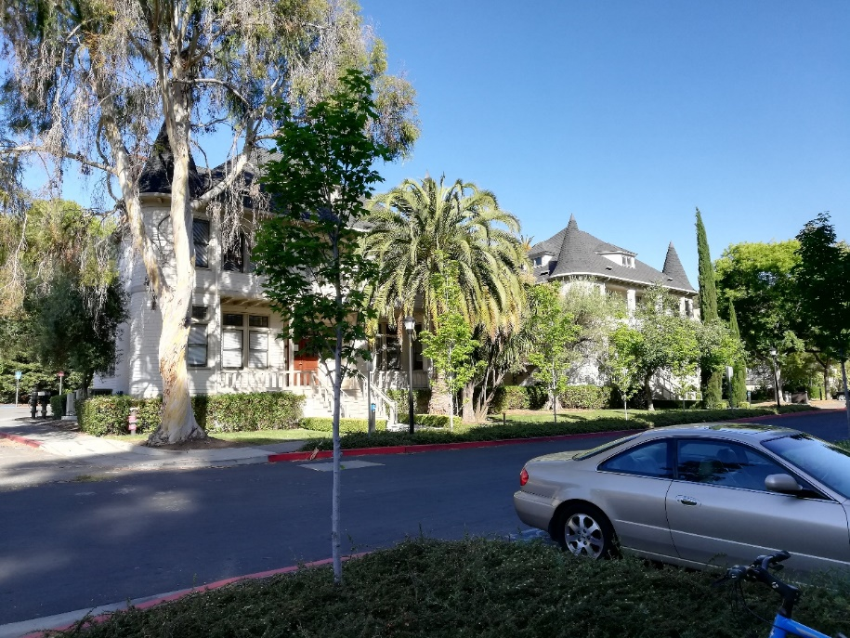

The plain-looking building on the campus

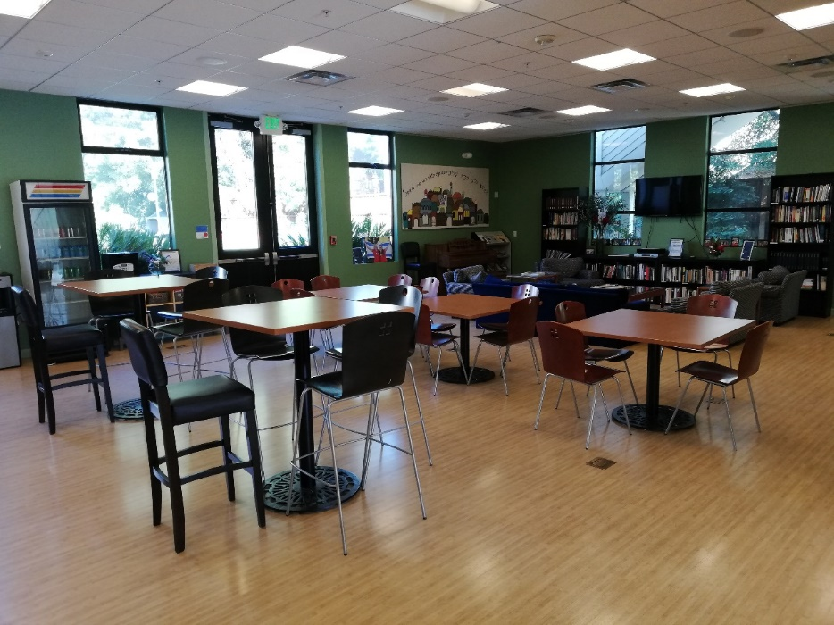

Our workshop

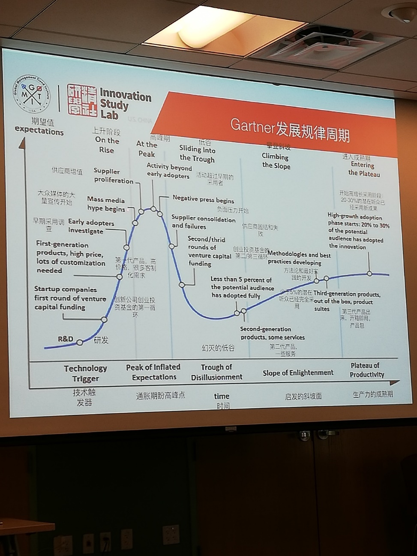

A diagram demonstrating different phases which a new product would go through

Google! Awesome!

“Google actually derives from the word “googol” which means the large number 10^100.” Our guide at Google explained to us. Google is not just about advanced search engine technology, it also has a deep company culture. “Burning Man Festival” is one of the most essential elements of google company culture. It’s my first time got to know there is such a festival. Burning Man is an annual event taking place in a desert in Nevada and it is about self-expression, community cooperation, experiment in community and art. As a participant, you can make prototypes of your innovative ideas and if they work our pretty well, some investors participating in the event may take your idea and co-operate with you to make it happen, and if they don’t, then you can just burn them out there. After all, it’s all desert there so you’ve got every freedom to do that. Every year, Google would organize a trip to such an event for its staff to learn the ideology behind it and to try out their creative ideas. Apart from “Burning Man Festival”, another cool thing about Google is that workers are given one day off on Friday to reflect on what they’ve done in the past four working days (Monday to Tuesday) and their current process on their projects as well as the plans for the following week. What’s more, there would be a conference held at Google monthly in which everyone from various departments are welcomed to bring and discuss their good ideas. If the ideas are approved by the board, people would be well funded to carry out the project. Even if they failed, they are not going be blamed but be encourage to try more instead. That’s a great opportunity that we don’t usually get in most workplaces in China. In China, most companies are not willing to risk having money wasted on something that may never work out while they could have invested the money on already existing products which bring tangible revenue. They more are focused on how to maintain their business and how to possibly enlarge their market instead of concentrated on how to innovate their products and services and to bring something new to the world. Just as what it says in the book *Creative Confidence* that “It takes courage to leave the land of certain outcomes and the comfort of what we know to try a new approach or share a wild-sounding idea.’’ After the “class” (it’s more like a meeting to me), we were all lost in all kinds of brain-storm in our heads. “Man, this place does have that kind of magic power that enables people to bring out their game-changing ideas and to change the world.’’ I thought.

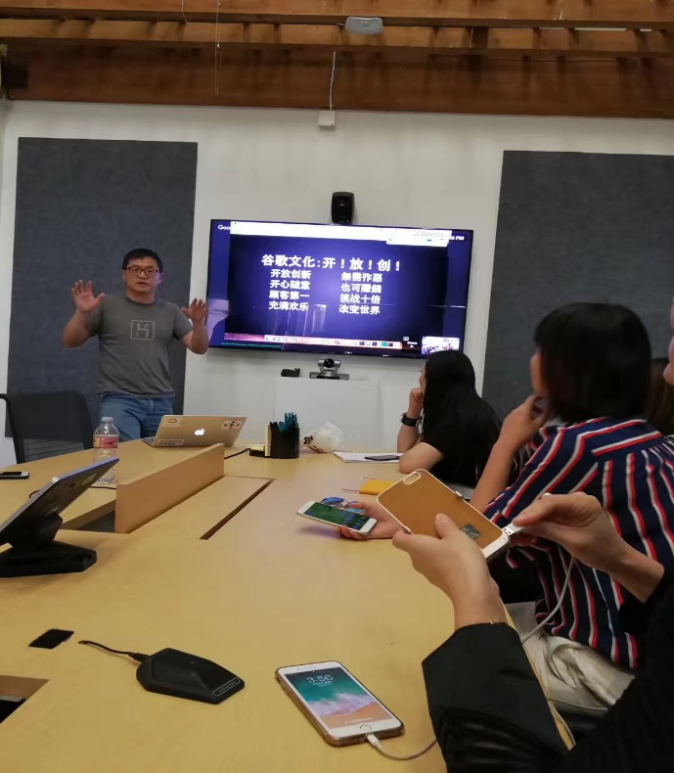

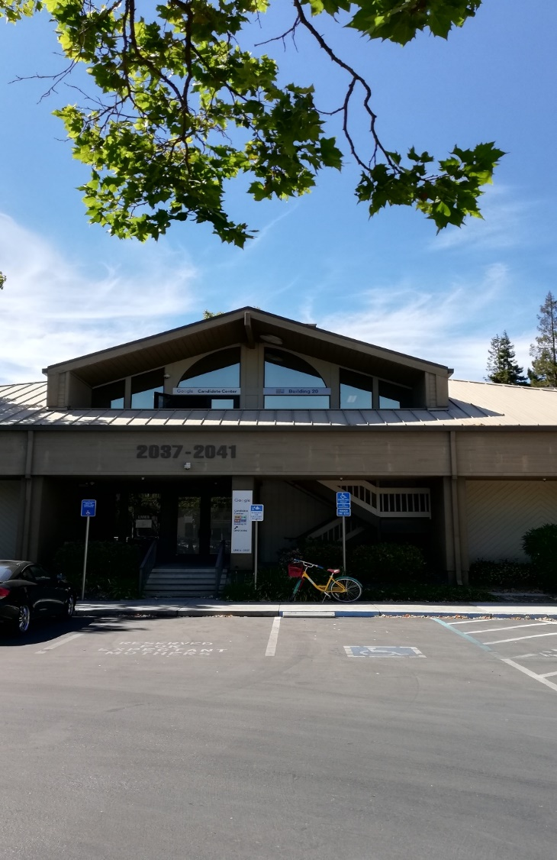Google Candidate Center

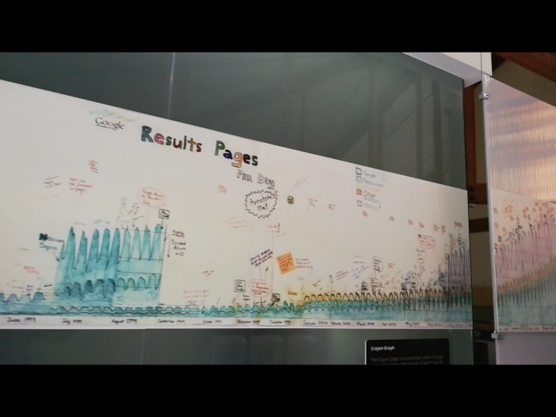

Google’s progression history chart

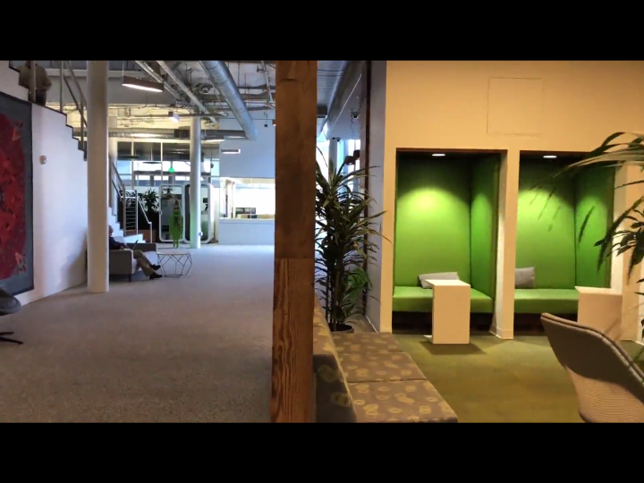

A quiet corner in the workspace

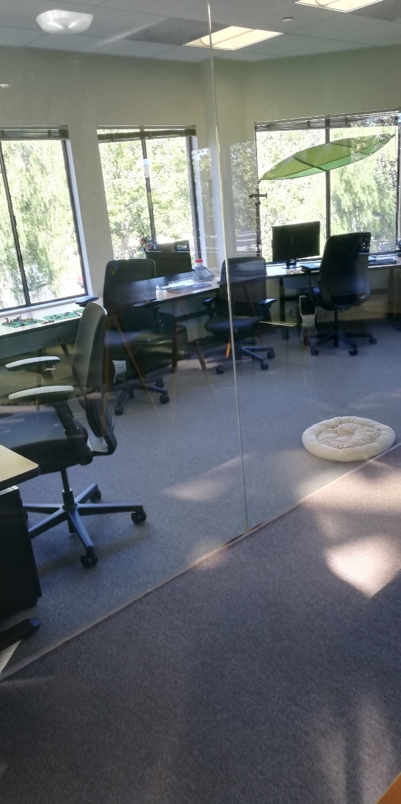

My first official *Strategic Innovation& Design Thinking* class

(Day 2)

Again, everyone was on the bus pretty on time ready for today’s exploration on this exotic land. On the way, Frank Gao told us that it was not him but Tamara Carleton going to give us the class today. Then Jack Zhang followed that Tamara was a very kind, approachable, and well-experienced teacher who had taught in the field of executive education, leadership training, and research services focused on innovation strategy and long-range planning… for years, and that we would for sure be given a very rewarding lesson. Hearing all these, everyone was pumped up like a bunch of excited children on their way to *Wonder land.* I was quite familiar with the name “Tamara Carleton” so I google it, and next thing I remembered was that I was bombarded by the endless information about Tamara Carleton such as Ph.D. graduating from Mechanical Engineering school at Stanford, CEO and the founder of Innovation Leadership Group, visiting professor of Osaka Institute of Technology and the list goes on. “Oh, man! What an amazing opportunity we were given to be given a lesson by such a great teacher!” I thought to myself. In no time, we were already on campus and the driver dropped us off in front of the building. We took seats in the classroom and were handed a pen and a big notebook read “Stanford University” on the cover by Jack Zhang. In one corner of the room installed a sink and by the sink there were fresh fruits, drinks, and deserts delicately laid out by Frank Gao, and “Any one still hungry after the breakfast? Your supply is over here.” He half-joked. Alright, desks and seats were in position, projector was well set, food and drinks were prepared, people were in top form, every thing felt great! Minutes later, the door opened, walked in a blond hair woman wearing a warm smile on her face--- Ms. Carleton, follow by a young man who we later found out that he was actually a professor of linguistics study from Washington University and he would be our translator for the following days. Shock after shock, I won’t feel too surprised if president Obama were the next one to walk into the classroom. Frank Gao gladly introduced Ms. Carleton to us in Chinese and Ms. Carleton introduced her self again in English “Hi, nice to meet you all! My name is Tamara Carleton, and I am pretty sure you have received great introduction from Jack and Frank already. So, let me talk a little a bit about myself. I run an innovation firm based here in Silicon Valley, but I also have other stuffs as well here at Stanford University. For most of the time, I work with large companies all around the world such as the Air Bus group, Microsoft, Toyota group and my focus is helping them think big, what you may call ‘Moon Shot’. And as part of the work, I use tools from this ‘How to’ guide that frank has mentioned which is the playbook for strategic foresight and innovation. Apart from that, I work with Stanford faculty and research labs in several ways. One way is I teach classes for managers like yourself, and most recently I’ve just started a program called ‘design your personal future’ and all these are online classes so you can be anywhere in world to take them and it allows me to hear from people about what do they see as important to their future. And the other half is working with the corporate E-Filliate programs called ‘Media X’ which looks at research questions, at the intersection of technology, society and media. So I help companies understand Stanford in breach thinking of doing. And then my most recent role is helping Stanford organize a summer inversion program called ‘Silicon Valley Innovation Academy’ and it is for high school and college students. In two weeks when the college students leave, you’ll have the other undergraduate students across the U.S. and the world coming here at Stanford and two hundred of them will learn about our Silicon Valley way of learning. So all of these keep me busy, but it’s nice for me to hear from groups like you.’’ While she continued, our translator interpreted all the English into Chinese in such an authentic way almost simultaneously. “He’s the true master of these two languages.” I thought, hoping one day I could do such a good job as he did too. “How is everyone today? I hope you all have adapted to the food, climate, and the clock here.” “So far so good!” I replied and she nodded at me. After warming up, Ms. Carleton started the lesson, saying “Today’s topic is ‘*Strategic Innovation& Design Thinking’* which means everything and nothing. So, I’ll probably raise many questions and introduce the topic which you’ll find that you may have many questions by the end of the week. And today I’m going to teach you two of the methods from the playbook. We’ll learn by doing; we’ll learn by asking questions, by reflecting in Stanford design way.” Then a diagram was demonstrated on the big screen, and M.s Carleton introduced us the “Ambiguity Curve”.

ambiguity

time

“At the early stage of the launch of the product, the ambiguity level is high, but as time goes by and the more evidence you receive, it diminishes gradually.” She explained. “What I want to do for the first part of this morning is to talk about how you build innovative teams. How you create them support them and think about team work.” Then she drew a “T-shaped” diagram on the white board.

Share information among staff

Tell stories/Speech

Read more books

Breadth

Biology

1. “T’’ person
2. “T” team

Accounting

Computer science

Depth

“So this is an important concept in Design Thinking. It’s the idea of ‘T-shaped person’. The stamp of the ‘T’ is depth which represents your deep knowledge. This is why you go to school to learn a particular discipline, have a degree that shows expertise. Across the top of the ‘T’ is the breadth, it’s your ability to work across disciplines in other fields. For instance, an engineer becomes a middle manager realizes he/she needs more knowledge and goes back to MBA. Another example for breadth that people say is Design Thinking, because you have the knowledge across different elements as the process of Design Thinking that helps you understand what a customer or a user need. However, not everybody can be ‘T-shaped person’, so one of our Stanford professors argues that you need to think about ‘T-shaped team’ and that means how might you think about across team members who’s ready for different areas of depth? Who’s ready for the areas of depth? Have you shared that across the group? What I encourage you to do in the next meeting is to talk about it as a team, let’s say what are the areas of depth/breadth? Who do we bring to complement what was missing? The concept of ‘T-shaped person’ is widely used in Silicon Valley.”

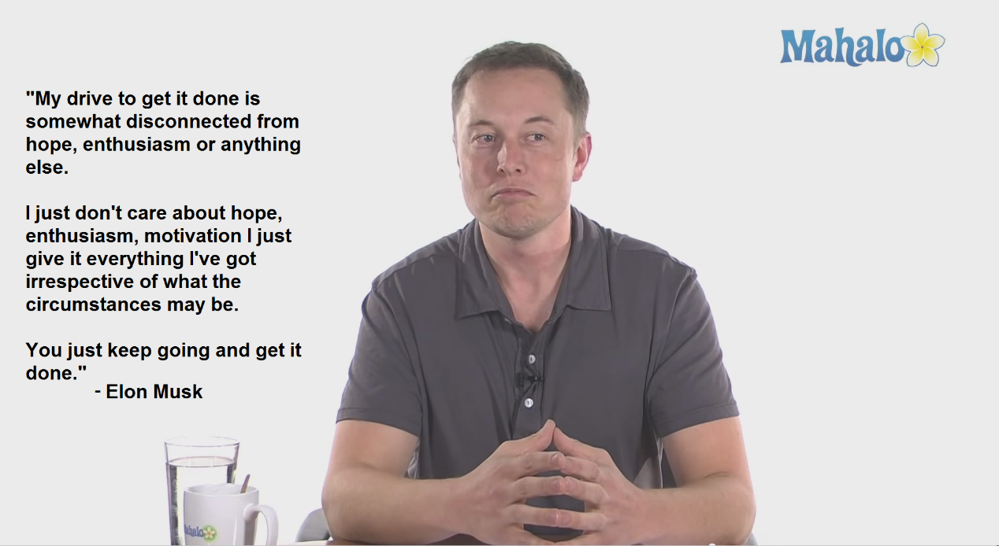

“Some of you may recognize this face.” She continued as she switched to next slide, showing us the picture. “This Elon Musk and he is one of the few individuals who have established several multi-billion-dollar businesses including SpaceX for rockets, Tesla for electric cars, *Solar City* for solar panels. Elon Musk is an extreme example of a ‘T-shaped person’. He is very technically trained, but his also works on how to be a business-thinker; how to be a showman because he tells outrageous stories; how to be a fund-raiser. He knows how important it is to develop talents.

As we can see in his first quote here says ‘Do everything you can to gather great people.’

* Do everything you can to gather great people.

“And the second lesson that I think is important to remember as you create conditions for your team is the second quote here on trying. Elon Musk says ‘Failure is an option here. If things are not failing, you’re not elevating enough’.’’

* Failure is an option here. If things are not failing, you’re not elevating enough.

“This is a belief that is very embeded here in Silicon Valley, failure is seen as an opportunity of learning. There is a phrase ‘fail early, fail often’. Actually, no body here wants to fail, and what they mean is that you’re willing try and try again and to share those stories of trying with each other.”

“Here’s another quote from the book *Shoe Dog* by Phil Knight---the co-founder of Nike company.”

* Don’t tell people how to do things, tell them what to do and let them surprise you with their results.

“Of course, what this means is you don’t like your manage, instead you help people see the bigger idea of what you’re trying to achieve, you support them with the resources, and you trust they can deliver it.

“Now, what I want you to do is to try one of these tools and the tool is a way to think about the team in your life and the people who you can turn from strangers in the crowd into strategic connections for the work.” Then she drew a big four-leaf clover on the white board and introduced us the *Crowd Clovers* tool.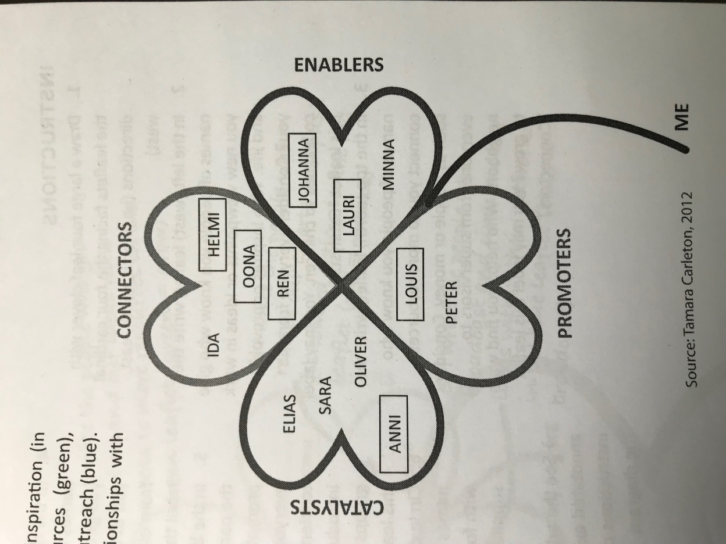

(picture from *Playbook for Strategic Foresight and Innovation)*

1. CATALYSTS: people who give you new viewpoints or ideas in work and life.
2. CONNERTORS: people who connect you to more resources, such as people or money.
3. ENABLERS: people who help you get things done. Who encourages you to take action?
4. PROMOTERS: people who promote you and your idea.

When to use it?

* To develop a map of your own or team’s innovation network.
* To assess which areas to bolster or change in your network.
* To evaluate the balance between formal and informal relationships within a network.

(reference to *Playbook for Strategic Foresight and Innovation p194-196)*

After that she then introduced us the idea of “Team of ‘Teams’”

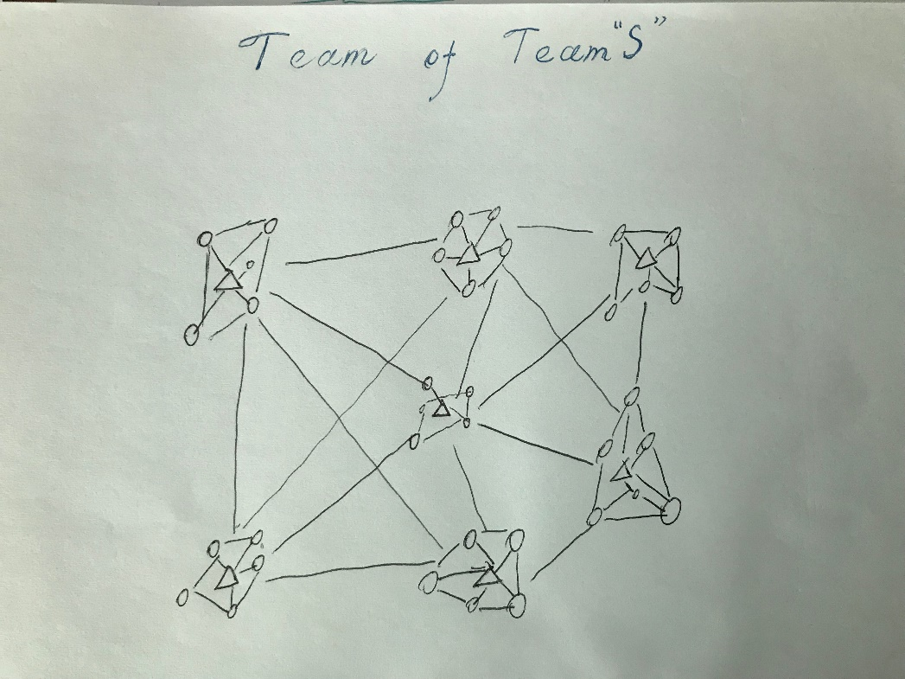

* There are close connections among members within a team and among different teams which form an innovative eco-system.

Traditional relationship among team members

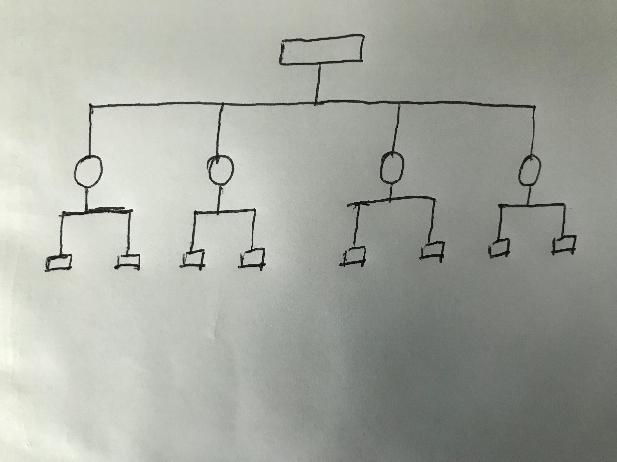

* There are only a few connections among team members
* Ideas flow up and down the hierarchy

After the break, M.s Carleton walked through the design history. She mentioned Sean Arno who was a professor of Engineering and Business and also a pioneer in the field of Design Thinking and he started a Design Thinking program at Stanford. She told us that what Sean Arno loved to do with his students was saying “As designers, you’re gonna try and design for yourself, you’ll discard all these assumptions about human. Imagine designing for alien race. You have to start to design totally strange, totally foreign and use that to really understand the process.” His courses were very exciting, very different at the time. Unfortunately, he died early at the age of 50, and over the years, all different groups at Stanford responded to different market demands of interests in terms of product design, robotic design, manufacturing, human computer and biology. It’s the design of all and the language of design of all, too. “So I share you these information not to impress you with the idea like over six decades of design but to show you there’s no one process and there’s not one definition. It’s the power of thinking like a designer, not just design.” She concluded.

After that, she introduced us the three overlapping circle strategy and at the center is the sweet spot (opportunity) leading to innovative outcome.

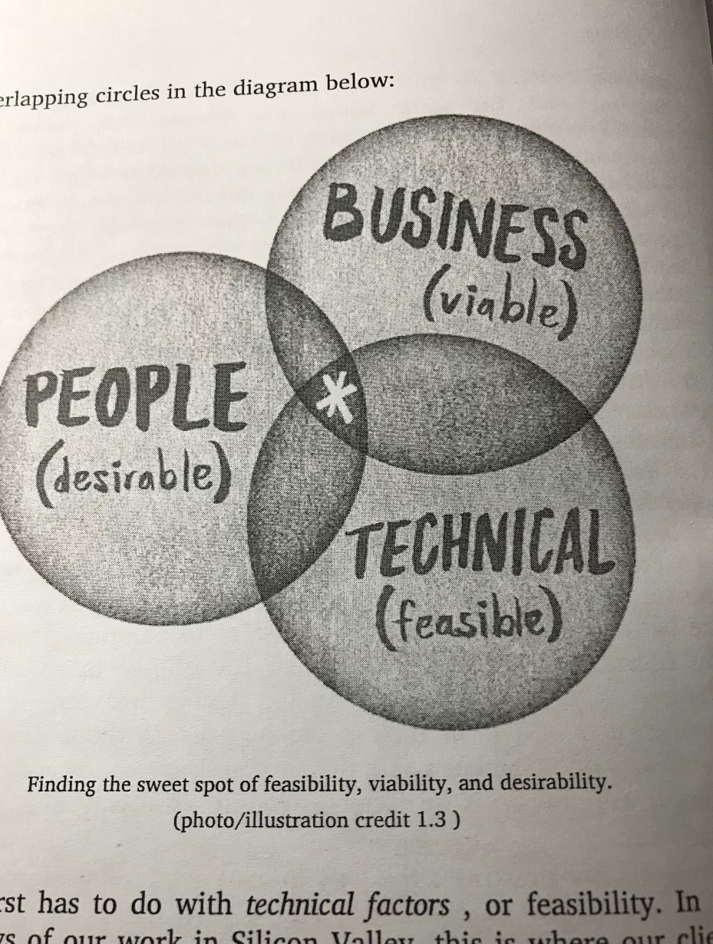

Picture from *Creative Confidence* P29

“This model is followed by IDEO---a famous global design and innovation company and is used in every innovation program. And in 2005, the Hasso Plattner Institute of Design was established at Stanford and it’s nicknamed the ‘d.school’, but it’s not a school, it does not grand a degree, does not sponsor rich research, it dose not have faculty there, the faculty come from all the other departments, but people work together kinda like *team of teams* model here at the d.school. However, by that time, many people have no idea about what d.school was due to it was a new concept. So, what is d.school? well, it all comes down to several different elements and they are often considered as the design mindsets.” (reference to the book *Creative Confidence* P36-37)

Design Mindsets:

1. The user at heart: you always think about human as the center of your plan.

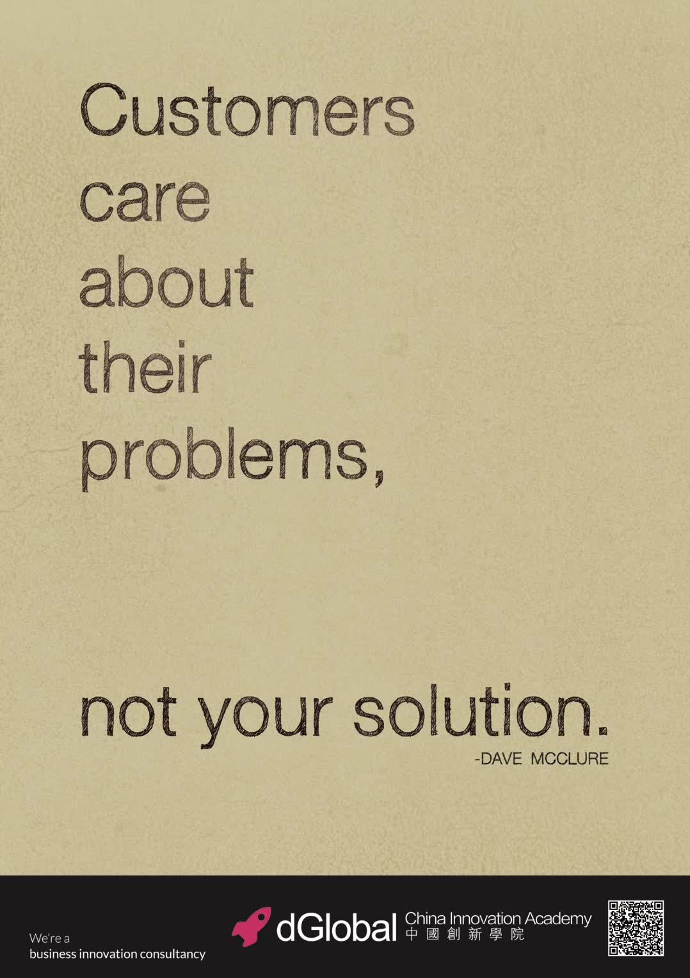

1. Biased toward action: you don’t plan forever, you take action, trying to always move towards getting things done.
2. Collaboration: team of teams

“at the time when d.school launched, it really tried to get students, faculty groups from different schools, different disciplines to work together on the same problem.” She added.

(Collaboration works especially well when members bring different backgrounds or perspectives to the team. That’s why we mix engineers, anthropologists, and business designers on the project teams with surgeons, food scientists, and behavioral economists. Bring together a variety of life experiences and contrasting perspectives results in a creative tension that often leads to more innovative and interesting ideas.) ---from book *Creative Confidence P184*

1. Prototyping: make rough mock-ups to help you build your early-stage idea

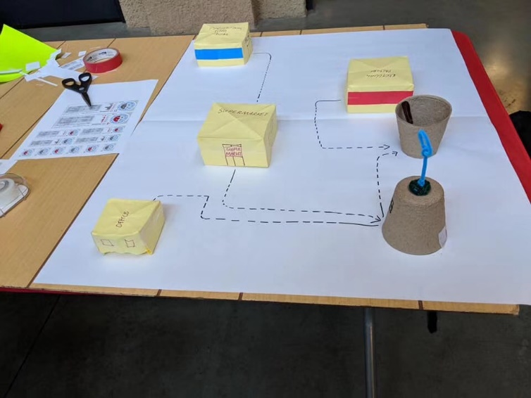

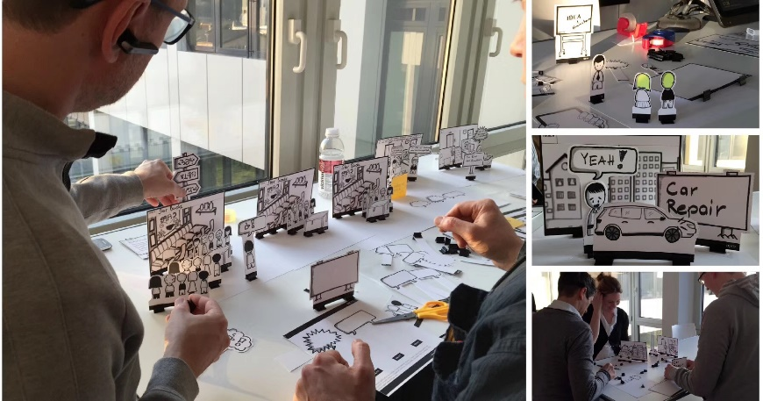

1. Show! Not tell: don’t just use power points, don’t just use reports, have your prototypes here the actual artifacts on the table, use them as a way to show or reveal your idea because that’s how you can advance a dialogue.

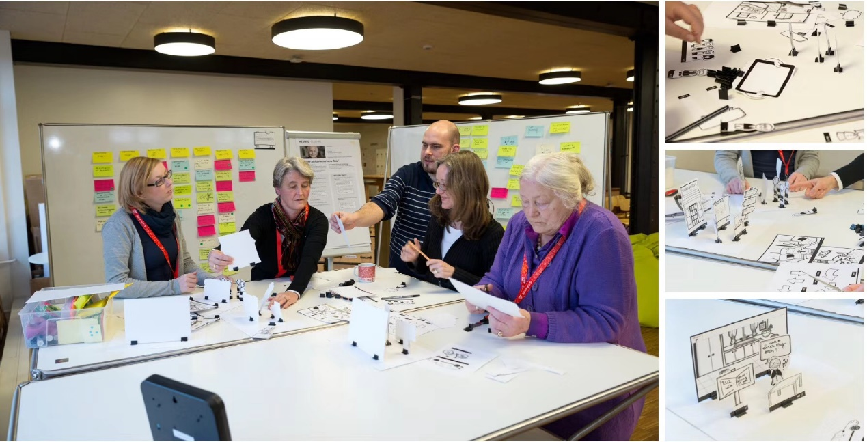

To help us better understand the innovation process, M.s Carleton gave us an exercise to do. In the exercise, there were nine sections and in in each section, we needed to answer particular questions in limited time. The following is the general layout of the worksheets.

1. Negative

First of all, ask your partner to describe the worst traveling experience as specific as possible. (6 minutes)

* Where? When?
* What did you do?
* How bad the situation was?

1. Positive

Now, ask your partner to describe the best traveling experience as specific as possible. (6 minutes)

* Where? When?
* What did you do?
* What made it a good traveling experience?

1. Put yourself in the other person’s shoes (4 minutes)

Imagine you’re going through the exactly same experience that your partner described. Think about how do you feel about it and why?

1. Keep track of your discovery (3 minutes)

* What were your partner’s needs for a good journey?
* What have you learnt from your partner’s feeling and motivation? What are the other factors that you’ve discovered but your partner missed out.

1. Reflect: (3 minutes)
2. I met ____.(your partner’s name & description about him/her)
3. I found that____. (What surprised you based on you’ve learnt)
4. How does he/she feel about it or what does he/she need?
5. Think of FIVE creative ways to meet customer’s needs. They could be products, services, ritual, manufacture, etc. (5 minutes)
6. Share your solutions with your partner and get the feedback. (8 minutes)

    

1. Mindful of progress: be sensitive to what you’re doing and why you’re doing. The journey is as important as the destination.

Need-finding and Benchmarking

Define the question

z

learn

build

Brainstorming

Test

Prototype

Ideate

Define

Empathize

9. Write a rough draft about the “future news” for your project (It should be compelling and explicit) (10 minutes)

8. Reflect again and generate a new solution (3 minutes)

Draw down your ideas

When we finished the exercise, I checked the time and it’s 12:10 already. How time flies when you’re so fully engaged in something.

HPE

(Hewlett Packard Enterprise)

After quick lunch on campus, we moved on to our next destination--- HPE head-quarter. When we arrived there, we were amazed by the gigantic office building in premium design style though some of us were trying to hide the excitement. Frost dark-colored wall with the company name “Hewlett Packard Enterprise” on it, the massive clean and shiny glass wall, all these bring you a sense of simplicity but absolutely premium quality. For customers, you are more than ever convinced that you can trust their products and services. For the staff, it gives you the feeling like you are working in the paradise every workday.

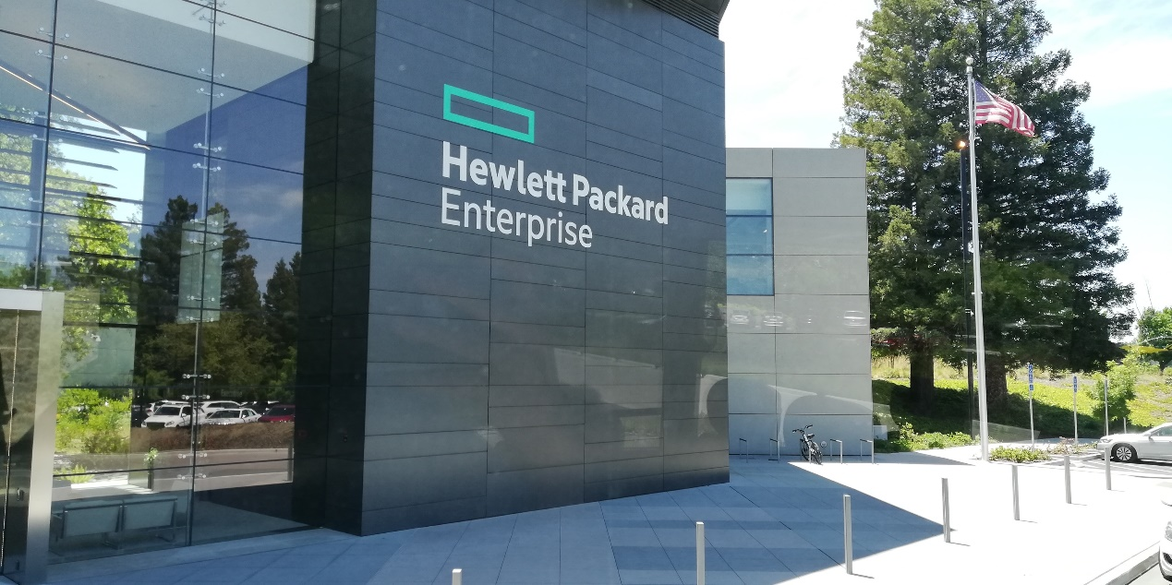

As we entered the building, I was more than surprised to find that there was an open-air park within the office building!

 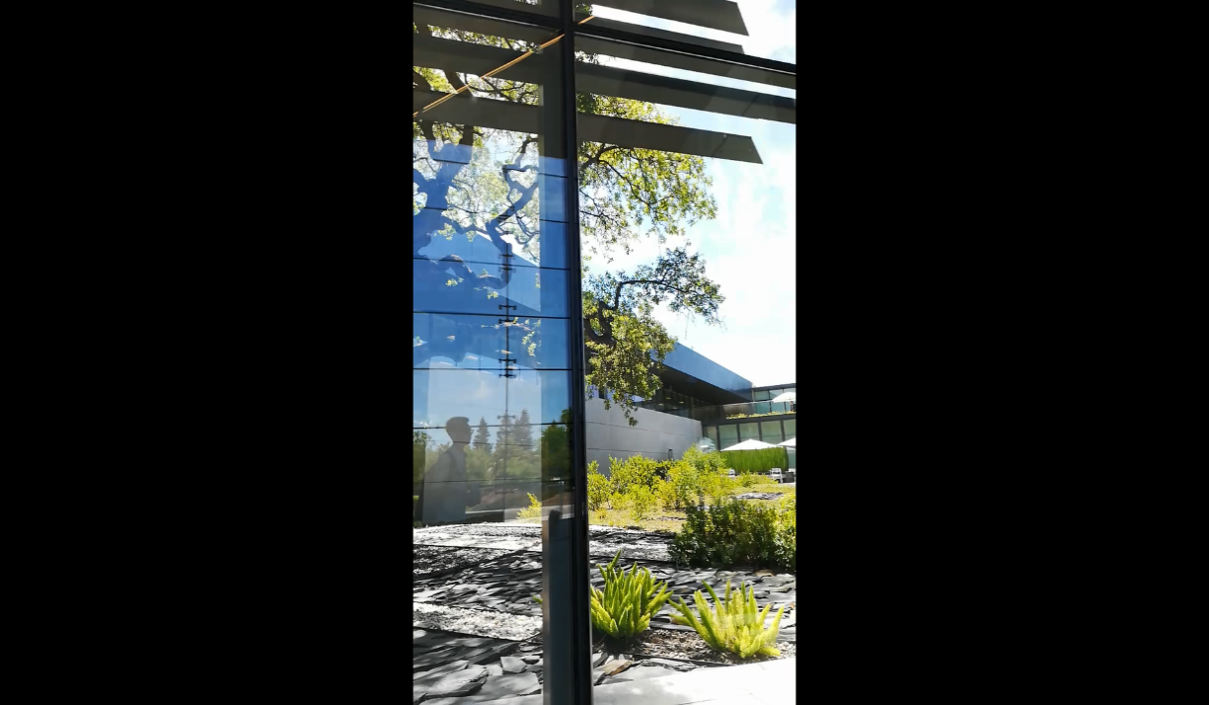

In the lobby, we were offered the visitor ID license and a guide came to us saying “This way please.” The two staffs standing on the both sides of the entrance warmly welcomed us. As we were walking in the hallway, I still couldn’t believe all these were actually happening. I mean just look around, we’ve got a row of HD screens on the glass wall on one side, a separate office above our head, the restroom was in great hygiene condition, and you literally cannot find any spot of dust in the whole area. Besides, it was so quiet. People talked in soft voice, and I walked slowly intentionally not wanting to make too much noise.

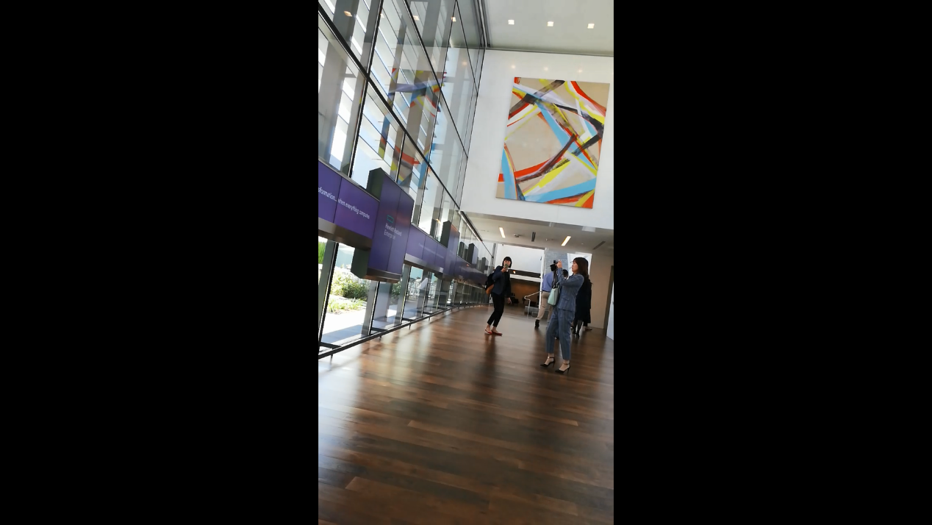 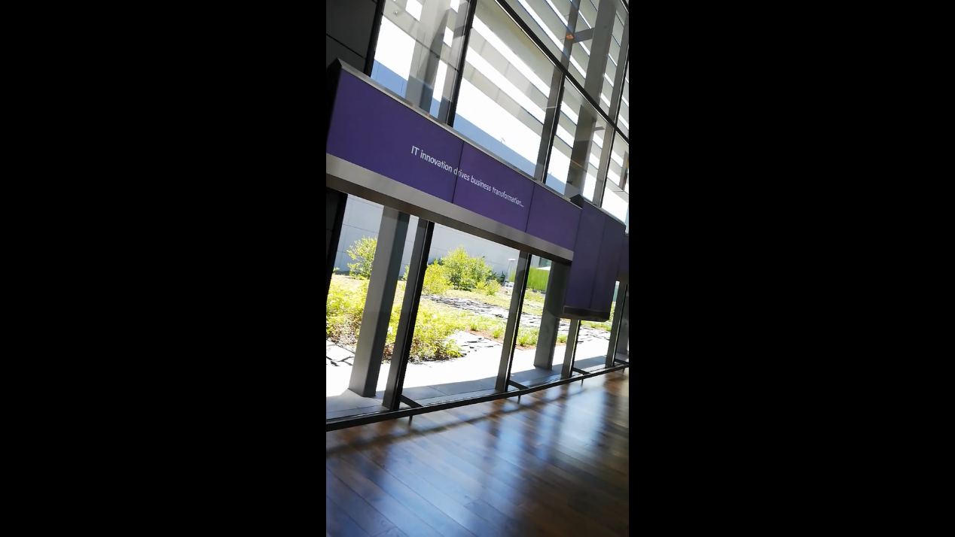 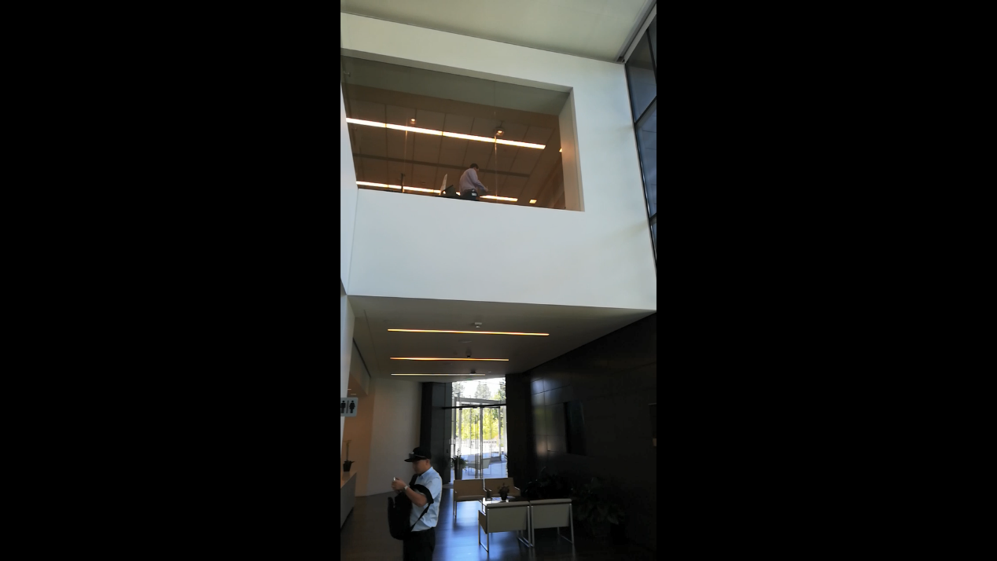

We were finally lead into a demonstration room with an Imax screen on the wall in front of us. A few minutes later, walked in a gentleman who claimed him self the representative of the first part today’s trip. He warmly greeted us and gave a short introduction about himself. Our incredible translator repeated his introduction in Chinese quickly.

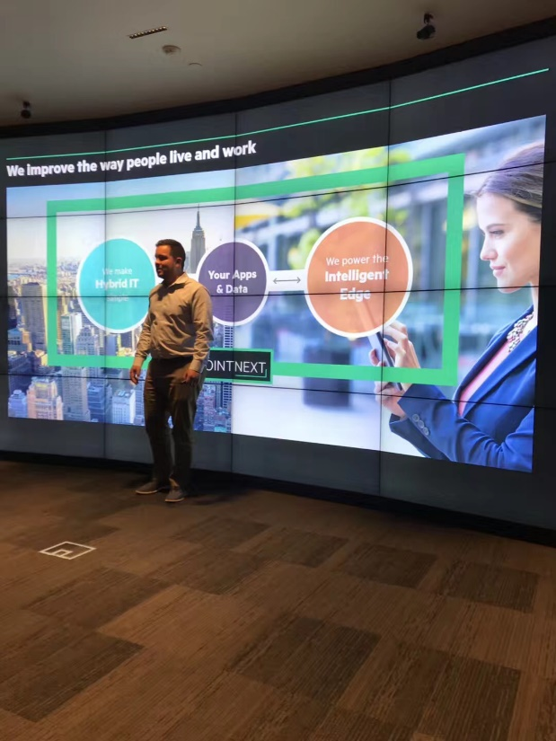

“Ok! So, let’s start with the early history of our company. This company was founded 77 years ago by Hewlett Dave. It was a representative of the early start-ups in Silicon Valley. This was before Instagram, Google, we-chat. This is the first start-up in Silicon Valley.” He said proudly. “Many years have passed until we got four major trends that we work in nowadays. Every customer that comes here wanna talk about data transformation. And these transformations nowadays belong to these four key areas: Internet things; machine learning and artificial intelligence; and cloud. Let’s take a look how these transforming the world. Technology is imbedded in everything ranging from transportation, smart cities to even agriculture.” Then he showed us a picture of a truck used in the field. “This is an example of a truck used for doing some cutting on some crops, and this truck actually has a chip on it which can take photos of each plantation. As it goes and taking the photos, the photos are analyzed by the chip in real time. Based on the data, it can make the decision like if the crops need fertilizers. So, it doesn’t spray fertilizers to everything only to those that are required. 45% saving on the use of fertilizer. With this example, we can see that we are living in a hyper connected world where everything and everyone is connected. A common conversation in our service center is smart city. A smart building; a smart factory, and all these are generating data, and these data can give us insight. It’s less about the data but more about the insight that we get from the data. We generate our world where everything will be in the insight. Therefore, every single industry is being disrupted by technology. Let’s come back to smart city, and I’ll let you select a topic you want to talk about.” One of us said “Education”. “So what’s interesting about education is teachers

…More to be continued

in the future (maybe tomorrow; maybe the next second; maybe …)